|  |  |
| --- | --- |
| Developing a web application to improve communication in the industry  Project proposal | Enrico Dreyer  31210783  Study Leaders: Dr. Suné Van Der Linde  Mr. Luke Coetzee  NWU Vanderbijlpark Campus  ITRI 671 BSc Hons 2021 |

Table of Contents

Table of Figures 1

1. Introduction 2

2. Problem statement 2

3. Project description 2

4. Aims and objectives of project 3

4.1 Primary objective 3

4.2 Second objective 3

4.2.1 Theoretical objects 3

4.2.2 Empirical objectives 3

5. Procedures and methods that will be used 3

5.1 Process model for this research 4

6. Approach to project management and project plan 4

7. Description of development platform, resources, and environments that will be used 5

8. Provisional chapter division 5

Chapter 1: Introduction 5

Chapter 2: Research methodology 5

Chapter 3: Literature review 5

Chapter 4: Data Analysis 5

Chapter 5: The artefact design 5

Chapter 6: Conclusion 5

9. Conclusion 6

10. References 7

# Table of Figures

Figure 1: Vaishnavi Process Model 4

# Introduction

Communication plays an important role in our daily lives. In the corporate world, businesses rely on effective communication to succeed. Effective communication is essential for a business since it enhances engagement between employees and strengthens the relationships with clients (Zambas, 2019). The overall efficiency in the work environment improves because of effective communication.

In the software development industry, communication remains a vital component of the core business. A typical process followed in the software development industry entails a client communicating requirements to a project manager and the project manager communicating the requirements to the developers. When those requirements are poorly communicated, it can affect the quality of the end product (EasyWorkNet, 2019). Thus, it is important for all the key stakeholders to have a good communication system.

The goal of this study is to develop a communication system that can be used to enhance communication between developers and management at a South African software development company. The system will … ?

In the next section, the background of the research will be discussed.

**Keywords:** design science research, productivity, communication, agile software development.

# Background to the study

Gee hier agtergrond oor julle maatskappy (jy hoef nie name te noem nie) en die proses wat gevolg word wanneer daar develop word, en highlight die importance dat die communication goed is want dit spaar tyd, resources, dus geld.

# Problem statement

As programmers, we want to keep the most important tabs open but lack the number of screens needed to achieve this. We are not regularly on our phones to read messages, thus making it harder for important messages to reach the team or developer. When developers have to look at their phones periodically it lowers productivity and creativity (Schrader, 2018).

This is common in smaller companies where they are using an Agile framework, where the project manager is busy with meetings. Meetings are not always at the office and the scope or requirements of the project can quickly change.

With an easy to access dashboard, developers can quickly look up to the artifact and see if there are any important announcements during the day, for instance, bugs that need to be fixed as soon as possible.

For this reason, this study proposes to develop an artefact that will …..

As jy wil kan jy research question in sit wat jou laat wonder het oor die problem en hoe jy dit gaan oplos bv:

Hoe kan DSR help om so ‘n artefact te develop?

Watter sagteware kan gebruik word om hierdie artefact te develop?

Watter belangrike features moet in die program wees?

# Project description

The goal of this study is to create an artifact that will improve communication in a company by minimizing the number of programs that are open on a programmer’s computer when working on a project. This study will explore solutions to improve communication and productivity in the industry by using an artifact that teams can use to send or upload important information.

The key concept is to have one dashboard shared between employees where everyone can see important information with ease. While focusing specifically on applications that can make it easier for project managers and teams to communicate.

# Aims and objectives of project

This study proposes the development of a communication dashboard that can easily be viewed in an office by all employees to allow easy access to important communication regarding specific software development projects. The primary and secondary objectives for the study are provided next. According to Syndicode (Team, 2017), the most used web applications for companies include Google Analytics, Slack, HubSpot, and Trello to name a few. Thus, it can easily be identified what type of applications are most common in the working environment.

## Primary objective

To develop a communication? dashboard for a South African software development company that allows for easy access to important communication relating to specific projects.

## Secondary objectives

Secondary objectives can be divided into theoretical and empirical objectives:

### 4.2.1 Theoretical objects

* To gain an understanding of Agile methodologies.
* To create a shared understanding of design science research and how it can be used to guide the development of an artefact.
* To identify commonly used web applications in industry.
* To establish whether there is a need for communication dashboards in the software development industry.

### 4.2.2 Empirical objectives

* To collect and analyse qualitative data in the form of interviews in order to understand…? with people in working in the software development industry.
* To develop a communication dashboard that will provide easy access to

# Procedures and methods that will be used

This study will use X for data collection and analysis, and Y as the overall methodology guiding the development of the artefact.

* 1. Data collection and analysis

Gee meer detail oor wat interviews is en hoe mens dit analyse –kyk na partcipants – wie gaan jy vra, hoe gaan jy hulle kies (m.a.w sampling), jy kan kyk na coding van Zang & Wildemuth vir analise.

* 1. Methodlogy

Bespreek DSR hier

For this study, the research methodology that is most applicable is design science research.

According to Vaishnavi (Vijay Vaishnavi, 2004), research methodology based on information technology is an outcome of design science. It focuses on the performance and development of artifacts, with the intention to improve an already functional artifact.

Research in this discipline is seen as improving and understanding human performance.

Interviews will be used in the planning phase to gather data on different companies and what applications or features they think are important and what they feel about using the system.

Sit nog vet by – gaan kyk na Hevner e nook hevner en Chatterjee, peffers

## Process model for this research

Vaishnavi and Keuchler (Vijay Vaishnavi, 2004) introduced a process model that included five steps when conducting a design science research project.

The steps include awareness of the problem, suggestion, development, evaluation, and conclusion as shown in figure 1. For this study, the Vaishnavi process model will be followed.

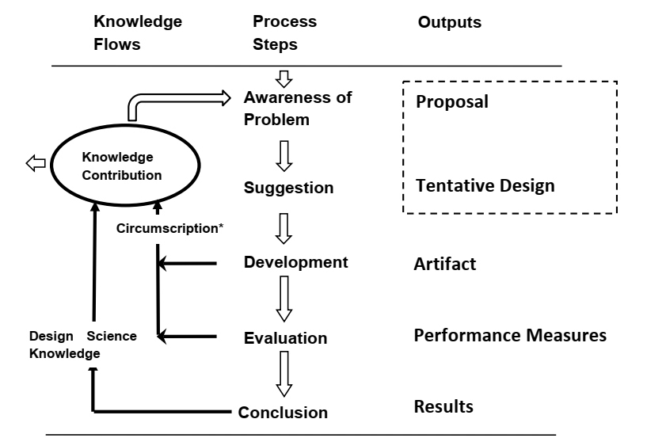

Figure : Vaishnavi Process Model (Vijay Vaishnavi, 2004)

Jy moet die prosesse beskryf

# Approach to project management and project plan

For this study, an Agile framework will be used. More specific will be the SCRUM methodology. SCRUM makes complex work transparent and easier to understand (Campbell, 2020).

This methodology was chosen because the scope can easily change, and you have constant communication with the customer. This increases customer satisfaction, and some parts of the system can already be used as the project progresses.

Each task of the project will be broken up into 2-week periods and at each start of the two weeks the project will undergo a sprint planning discussion where the backlog items will be prioritized, and some tasks will be placed back in the sprint backlog.

At the end of each sprint, every task should be finished and ready to be released. Each task will also undergo a “show me”, “code review”, “merge” and a “QA”. This will reduce the risk of having bugs in the artifact because there is a user acceptance test layer.

# Description of development platform, resources, and environments that will be used

The artifact for this study will be a web application. According to Paul Stanley Software (Stanley, n.d.), there are a number of advantages to creating a web application. Users do not have to install an application because every computer has a browser. It is easy to update, and users have direct access to these updates.

For the user interface, Vue.JS will be used as a binding framework because It is easy to understand, small in terms of size, and flexible (Vivek, 2018), as well as HTML, JavaScript, and CSS. For the backend Visual Studio’s Web API will be used and written in C#. The Database management system that will be used is SQL SERVER.

The database and website will be hosted on Azure.

Afdeling – Rigour & Validity & reliability

Guidelines oor DSR research

Afdeling - Ethical considerations

# Provisional chapter division

The study will include the following chapters:

### Chapter 1: Introduction

In this chapter the underlying problem will be introduced as well as the methodology and principles that is going to be used. The objectives will be stated, and development platforms will be noted.

### Chapter 2: Research methodology

In this chapter the research paradigm that is applicable to the study will be explained. It will also elaborate on the design science and why it was chosen for the study.

### Chapter 3: Literature review

Existing literature will be discussed in this chapter as well as key concepts of the study.

### Chapter 4: Data Analysis

In this chapter data gathering techniques will be discussed and how the data will be analysed to improve the existing concept.

### Chapter 5: The artefact design

This chapter will be used to display the dashboard artifact.

### Chapter 6: Conclusion

This chapter will conclude and give an overview of the study.

# Summary

Summarise in terme van die problem ook.

This project proposal serves as an introduction to the research of the paper. The objectives have been defined as well as what approach will be taken.

The aim of the study will be to develop a web application to improve communication in the industry. This web application should be flexible because every company uses different applications and if the expectations are not met then the application is of no use.

The Vaishnavi process model will be followed to develop the application, and the SCRUM methodology will be of use to organize each phase. Interviews will be used to gather data on what information should display on the dashboard and what is the importance.

# 10. References

Campbell, J. (2020, June 5). *Scrum Methodology: Breaking Down the Scrum Framework*. Retrieved from SCRUM explainer: https://scrumexplainer.com/scrum/scrum-methodology/

EasyWorkNet. (2019, Decemeber 27). *The Importance of Communication in Software Development Teams*. Retrieved from EasyWork: https://www.easyworknet.com/web-development/importance-communication-software-development-teams/#:~:text=When%20it%20comes%20to%20software%20development%2C%20communication%20is,the%20solution%20to%20the%20client%20in%20good%20time.

Kuechler, W. a. (2012). *A framework for theory development in design science research: Multiple perspectives*. Retrieved from https://citeseerx.ist.psu.edu/viewdoc/download?doi=10.1.1.348.7047&rep=rep1&type=pdf

Schrader, J. (2018, July 30). *How Your Cell Phone Habits Impact Your Productivity*. Retrieved from Psychology today: https://www.psychologytoday.com/us/blog/why-bad-looks-good/201807/how-your-cell-phone-habits-impact-your-productivity

Stanley, P. (n.d.). *Advantages of Web Applications*. Retrieved from Bespoke Software Development: https://www.pssuk.com/AdvantagesWebApplications.aspx

Team, S. (2017, August). *Top-10 web applications for business*. Retrieved from Syndicode: https://syndicode.com/blog/top-10-web-applications-for-business/

Vijay Vaishnavi, B. K. (2004, January 20). *Design Science Research in Information Systems*. Retrieved from desrist.org: http://desrist.org/design-research-in-information-systems/

Vivek. (2018, October 14). *7 advantages of using Vue.JS | The Progressive Framewor*. Retrieved from Inkoop: https://www.inkoop.io/blog/7-advantages-of-using-vue-js/#:~:text=%207%20advantages%20of%20using%20Vue.JS%20%7C%20The,popular%20among%20the%20web%20developers%20because...%20More%20

Zambas, J. (2019, February 5). *The Importance of Effective Communication in the Workplace*. Retrieved from Career Addict: https://www.careeraddict.com/the-importance-of-effective-communication-in-the-workplace#:~:text=Effective%20communication%20in%20the%20workplace%20is%20an%20integral,effectively%2C%20the%20results%20are%20detrimental%20to%20the%20business.